**Project Management App**

**Version 1.0**

**Team A**

**CSC-354**

**Fall 2015**

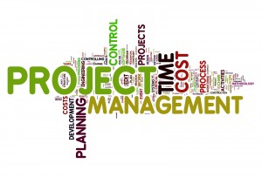

09/08/2015

Professor: Dr. Joo Tan

Authors: Hector Richiez, Jennifer Li, and Tyler Mariano